Clinical Trial Randomization Simulator – Summary
Adapted from Rock Paper Scissors project for Clinical Research Education in the Health Industry

Problem Statement:
Clinical trials require fair, unpredictable assignment of patients to treatment arms. Poor randomization (or none) introduces selection bias and can invalidate results. Students and junior researchers often struggle to appreciate why “just alternate” or “clinician choice” is unacceptable. This project turns the familiar random-choice mechanics of a simple game into an interactive teaching tool that makes the consequences of different allocation strategies visible through Monte-Carlo simulation.

Solution Strategy:
1. Implement four allocation methods: simple randomization, permuted-block, always-Treatment (extreme bias), and sequential alternation.
2. Provide a single-trial summary (counts, % Treatment, imbalance) and a Monte-Carlo engine that repeats the process thousands of times.
3. Visualize the resulting distributions so learners can see at a glance which methods stay balanced and which do not.
4. Expose tunable parameters (N, number of trials, method, ratio) so students can experiment and discover the effect of sample size and design choices.

Solution:
Files: Clinical_Trial_Randomization_Practice_Skeleton.ipynb • Clinical_Trial_Randomization_Solution.ipynb
• clinical_trial_flowchart.png • clinical_trial_simulation.png • this 1-page report
Key result from 2 000 simulated trials of N = 100: Simple randomization centres on 50 % with SD ≈ 5 %; block randomization is essentially perfect; “Always Treatment” is 100 % biased; sequential alternation looks balanced but is fully predictable (and therefore not valid randomization).
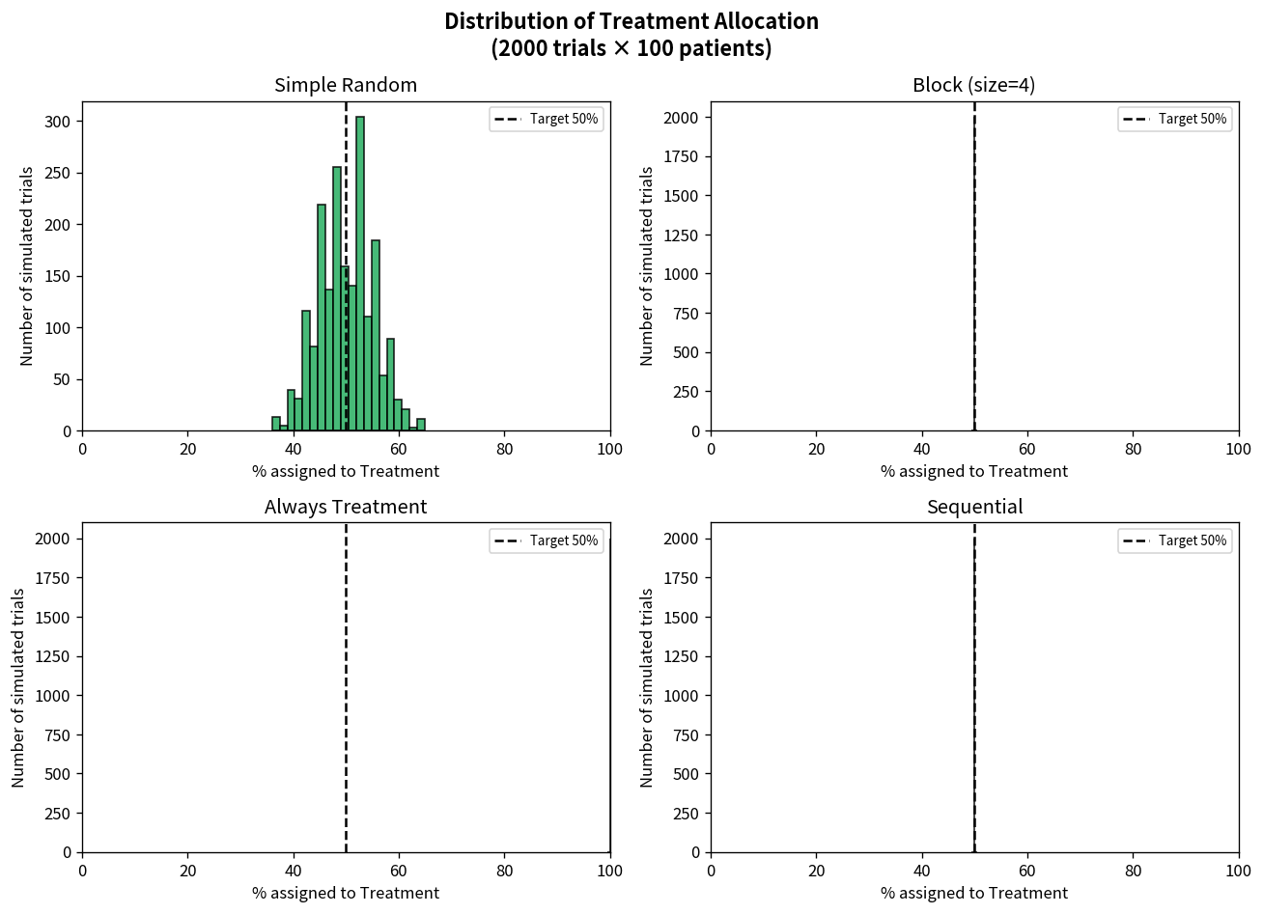

Key Takeaways:
• Fair randomization (simple or blocked) keeps expected allocation on target and limits chance imbalance.
• Deterministic strategies create systematic imbalance – the educational analogue of selection bias.
• Larger sample size dramatically reduces the probability of large chance imbalances under simple randomization.
• Monte-Carlo simulation is the same technique statisticians use to evaluate a randomization scheme before a real trial starts.
• The programming patterns from a simple game transfer directly to rigorous clinical-research education tools.

